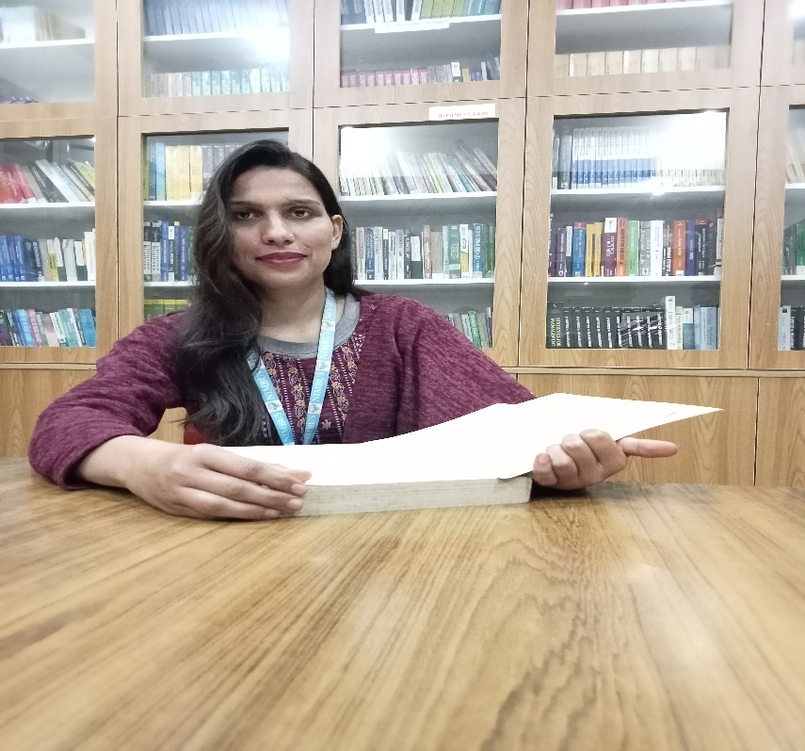

**Vandana Bhandari**

**Assistant professor**

**Area**

Primary Area : Human Resources Management

Secondary Area : Marketing Management

**Contact**

Email : Vandnab09@gmail.com

Phone : 7983014879

**Education**

B.Sc (Zoology, Botany , Chemistry) SRT CAMPUS

MBA (Human Resource Management) Sri Guru Ram Rai University Dehradun

**Teaching**

* Human Resource Management
* Organizational Behaviour
* Company Law
* Business Policy and Strategy

**Research Area**

* HRM Practices
* Labour and Social Welfare
* Organizational Behaviour

**Academic Experience**

Faculty Member, Minerva Group of Institutions, September 2022 onwards

Faculty Member , Nimbus Academy Management, October 2023 onwards

**Professional Experience**

Nimbus Academy of Management